ACKNOWLEDGMENT AND AUTHORIZATION FOR BACKGROUND CHECK

I acknowledge receipt of the separate stand-alone Disclosure and certify that I have read and understand it and this authorization. I hereby authorize the obtaining of “consumer reports” and/or “investigative consumer reports” by [INSERT NAME OF COMPANY]. To this end, I hereby authorize, without reservation, any law enforcement agency, administrator, state or federal agency, institution, school or university (public or private), information service bureau, employer, or insurance company to furnish any and all background information requested by IntelliCorp, 3000 Auburn Drive, Suite 410, Beachwood, Ohio 44122; Tel. No. 1.888.946.8355; www.intellicorp.net.

I do _______do not_________ authorize you to contact, through IntelliCorp, my current employer for Employment and Reference Verifications. (Checking “I do” will authorize inquiries to the Human Resources Department and to any listed supervisors.)

I also consent to have any legally required notices sent electronically.
- You may request a free copy of any consumer report or investigative consumer report we obtain on you by checking the box.

______________________________
Printed Name
______________________________ ________________
Signature Date
______________________________ ________________
Parent or Legal Guardian Signature Date
(for searches conducted on minors under
the age of 18)
PERSONAL DATA

Last Name First Name Middle Name

Current Address Dates Lived Here

Date of Birth Other Names Used (including maiden name) Years Used

Social Security Number Driver's License # DL State

Email address (may be used for official correspondence)

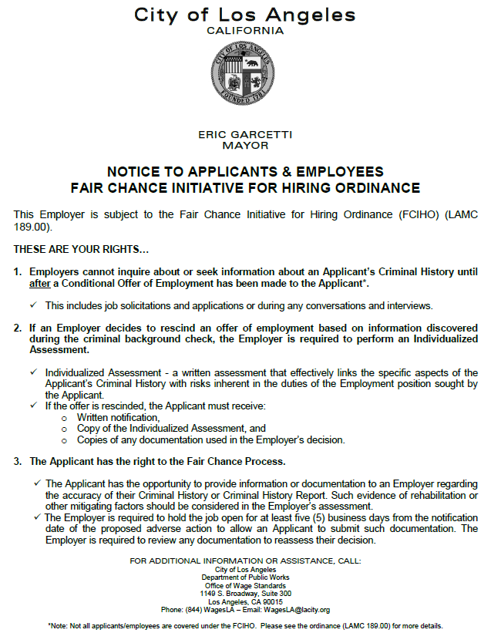
Form FCIHO, Rev. 08/18

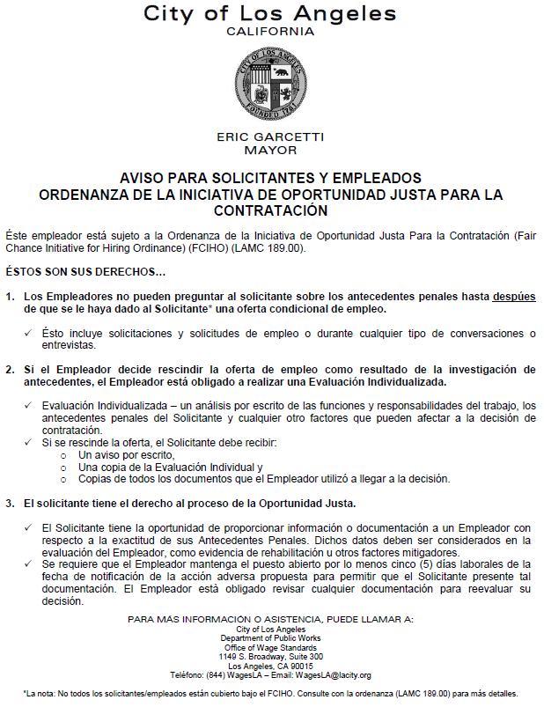
Form FCIHO, Rev. 08/18

Para información en español, visite www.consumerfinance.gov/learnmore o escribe a la Consumer Financial Protection Bureau, 1700 G Street NW, Washington, DC 20552.

A Summary of Your Rights Under the Fair Credit Reporting Act

The federal Fair Credit Reporting Act (FCRA) promotes the accuracy, fairness, and privacy of information in the files of consumer reporting agencies. There are many types of consumer reporting agencies, including credit bureaus and specialty agencies (such as agencies that sell information about check writing histories, medical records, and rental history records). Here is a summary of your major rights under FCRA. For more information, including information about additional rights, go to www.consumerfinance.gov/learnmore or write to: Consumer Financial Protection Bureau, 1700 G Street NW, Washington, DC 20552.

- You must be told if information in your file has been used against you. Anyone who uses a credit report or another type of consumer report to deny your application for credit, insurance, or employment – or to take another adverse action against you – must tell you, and must give you the name, address, and phone number of the agency that provided the information.

- You have the right to know what is in your file. You may request and obtain all the information about you in the files of a consumer reporting agency (your “file disclosure”). You will be required to provide proper identification, which may include your Social Security number. In many cases, the disclosure will be free. You are entitled to a free file disclosure if:

  - a person has taken adverse action against you because of information in your credit report;
  - you are the victim of identity theft and place a fraud alert in your file;
  - your file contains inaccurate information as a result of fraud;
  - you are on public assistance;
  - you are unemployed but expect to apply for employment within 60 days.

In addition, all consumers are entitled to one free disclosure every 12 months upon request from each nationwide credit bureau and from nationwide specialty consumer reporting agencies. See www.consumerfinance.gov/learnmore for additional information.

- You have the right to ask for a credit score. Credit scores are numerical summaries of your credit-worthiness based on information from credit bureaus. You may request a credit score from consumer reporting agencies that create scores or distribute scores used in residential real property loans, but you will have to pay for it. In some mortgage transactions, you will receive credit score information for free from the mortgage lender.

- You have the right to dispute incomplete or inaccurate information. If you identify information in your file that is incomplete or inaccurate, and report it to the consumer

reporting agency, the agency must investigate unless your dispute is frivolous. See www.consumerfinance.gov/learnmore for an explanation of dispute procedures.

- Consumer reporting agencies must correct or delete inaccurate, incomplete, or unverifiable information. Inaccurate, incomplete, or unverifiable information must be removed or corrected, usually within 30 days. However, a consumer reporting agency may continue to report information it has verified as accurate.

- Consumer reporting agencies may not report outdated negative information. In most cases, a consumer reporting agency may not report negative information that is more than seven years old, or bankruptcies that are more than 10 years old.

- Access to your file is limited. A consumer reporting agency may provide information about you only to people with a valid need – usually to consider an application with a creditor, insurer, employer, landlord, or other business. The FCRA specifies those with a valid need for access.

- You must give your consent for reports to be provided to employers. A consumer reporting agency may not give out information about you to your employer, or a potential employer, without your written consent given to the employer. Written consent generally is not required in the trucking industry. For more information, go to www.consumerfinance.gov/learnmore.

- You may limit “prescreened” offers of credit and insurance you get based on information in your credit report. Unsolicited “prescreened” offers for credit and insurance must include a toll-free phone number you can call if you choose to remove your name and address from the lists these offers are based on. You may opt out with the nationwide credit bureaus at 1-888-5-OPTOUT (1-888-567-8688).

- The following FCRA right applies with respect to nationwide consumer reporting agencies:
CONSUMERS HAVE THE RIGHT TO OBTAIN A SECURITY FREEZE
You have a right to place a “security freeze” on your credit report, which will prohibit a consumer reporting agency from releasing information in your credit report without your express authorization. The security freeze is designed to prevent credit, loans, and services from being approved in your name without your consent.
However, you should be aware that using a security freeze to take control over who gets access to the personal and financial information in your credit report may delay, interfere with, or prohibit the timely approval of any subsequent request or application you make regarding a new loan, credit, mortgage, or any other account involving the extension of credit.
As an alternative to a security freeze, you have the right to place an initial or extended fraud alert on your credit file at no cost. An initial fraud alert is a 1-year alert that is

placed on a consumer’s credit file. Upon seeing a fraud alert display on a consumer’s credit file, a business is required to take steps to verify the consumer’s identity before extending new credit. If you are a victim of identity theft, you are entitled to an extended fraud alert, which is a fraud alert lasting 7 years.

A security freeze does not apply to a person or entity, or its affiliates, or collection agencies acting on behalf of the person or entity, with which you have an existing account that requests information in your credit report for the purposes of reviewing or collecting the account. Reviewing the account includes activities related to account maintenance, monitoring, credit line increases, and account upgrades and enhancements.

- You may seek damages from violators. If a consumer reporting agency, or, in some cases, a user of consumer reports or a furnisher of information to a consumer reporting agency violates the FCRA, you may be able to sue in state or federal court.

- Identity theft victims and active duty military personnel have additional rights. For more information, visit www.consumerfinance.gov/learnmore.

States may enforce the FCRA, and many states have their own consumer reporting laws. In some cases, you may have more rights under state law. For more information, contact your state or local consumer protection agency or your state Attorney General. For information about your federal rights, contact:

TYPE OF BUSINESS: | CONTACT:
1.a. Banks, savings associations, and credit unions with total assets of over $10 billion and their affiliates  b. Such affiliates that are not banks, savings associations, or credit unions also should list, in addition to the CFPB: | - Consumer Financial Protection Bureau 1700 G Street NW  Washington, DC 20552  - Federal Trade Commission Consumer Response Center 600 Pennsylvania Avenue NW Washington, DC 20580  (877) 382-4357
2. To the extent not included in item 1 above:  - National banks, federal savings associations, and federal branches and federal agencies of foreign banks  - State member banks, branches and agencies of foreign banks (other than federal branches, federal agencies, and Insured State Branches of Foreign Banks), commercial lending companies owned or controlled by foreign banks, and organizations operating under section 25 or 25A of the Federal Reserve Act.  - Nonmember Insured Banks, Insured State Branches of Foreign Banks, and insured state savings associations  - Federal Credit Unions | a. Office of the Comptroller of the Currency Customer Assistance Group  P.O. Box 53570 Houston, TX 77052  b. Federal Reserve Consumer Help Center  P.O. Box 1200 Minneapolis, MN 55480  - Division of Depositor and Consumer Protection National Center for Consumer and Depositor Assistance Federal Deposit Insurance Corporation  1100 Walnut Street, Box #11 Kansas City, MO 64106  - National Credit Union Administration Office of Consumer Financial Protection 1775 Duke Street  Alexandria, VA 22314
3. Air carriers | Assistant General Counsel for Office of Aviation Protection Department of Transportation  1200 New Jersey Avenue SE Washington, DC 20590
4. Creditors Subject to the Surface Transportation Board | Office of Public Assistance, Governmental Affairs, and Compliance Surface Transportation Board  395 E Street SW Washington, DC 20423
5. Creditors Subject to the Packers and Stockyards Act, 1921 | Nearest Packers and Stockyards Division Regional Office
6. Small Business Investment Companies | Associate Administrator, Office of Capital Access United States Small Business Administration  409 Third Street SW, Suite 8200  Washington, DC 20416
7. Brokers and Dealers | Securities and Exchange Commission 100 F Street NE  Washington, DC 20549
8. Institutions that are members of the Farm Credit System | Farm Credit Administration 1501 Farm Credit Drive McLean, VA 22102-5090
9. Retailers, Finance Companies, and All Other Creditors Not Listed Above | Federal Trade Commission Consumer Response Center 600 Pennsylvania Avenue NW Washington, DC 20580  (877) 382-4357
4

Para obtener información en español, visite www.consumerfinance.gov/learnmore o escriba a: Consumer Financial Protection Bureau, 1700 G Street NW, Washington, DC 20552.

Un resumen de sus derechos en virtud de la Ley de Informe Justo de Crédito

La Ley de Informe Justo de Crédito (Fair Credit Reporting Act, FCRA, por sus siglas en inglés), una ley federal, fomenta la exactitud, imparcialidad y privacidad de la información en los archivos de las agencias de informes del consumidor. Existen muchos tipos de agencias de informes del consumidor, incluidas las agencias de crédito (credit bureaus) y las agencias especializadas (como las agencias que venden información sobre el historial de extensión de cheques, registros médicos y registros de historial de alquiler). A continuación, se presenta un resumen de sus principales derechos en virtud de la FCRA. Para obtener más información, incluyendo información sobre derechos adicionales, visite www.consumerfinance.gov/learnmore o escriba a: Consumer Financial Protection Bureau, 1700 G Street NW, Washington, DC 20552.

- Deben notificarle si la información contenida en su archivo se ha utilizado en su contra. Todo aquel que utilice un informe de crédito u otro tipo de informe de consumidor para denegar su solicitud de crédito, seguro o empleo, o para emprender otra acción adversa en su contra, debe informarle y debe darle el nombre, la dirección y el número de teléfono de la agencia que proporcionó esa información.

- Usted tiene derecho a saber lo que contiene su archivo. Usted puede solicitar y obtener toda la información registrada bajo su nombre en los archivos de una agencia de informe del consumidor (divulgación de su información). Usted deberá proporcionar una prueba de su identidad, que puede incluir su número de Seguro Social. En muchos casos, la divulgación de la información de su archivo será gratuita. Usted tiene derecho a recibir una copia gratuita de su archivo si:

  - Una persona ha emprendido una acción adversa en su contra debido a la información contenida en su informe de crédito.
  - Usted es víctima de un robo de identidad y coloca una alerta de fraude en su archivo.
  - Su archivo contiene información inexacta como resultado de fraude.
  - Usted recibe asistencia pública.
  - Usted está desempleado pero prevé solicitar empleo en un plazo de 60 días.

Asimismo, todos los consumidores tendrán derecho a recibir una copia gratuita de la información registrada en su archivo cada 12 meses si así se lo solicitan a cada agencia de crédito a nivel nacional y a las agencias especializadas de informe del consumidor a nivel nacional. Para obtener más información, visite www.consumerfinance.gov/learnmore.

- Usted tiene derecho a pedir su puntuación de crédito. Las puntuaciones de crédito son resúmenes numéricos de su solvencia crediticia basados en la información de las agencias de crédito. Usted puede solicitar su puntuación de crédito a las agencias de informes del consumidor que generan o distribuyen los puntajes utilizados en préstamos de bienes raíces residenciales, pero tendrá que pagar un cargo. En algunas transacciones hipotecarias, el prestamista le dará información sobre su puntuación de crédito gratuitamente.

- Usted tiene derecho a impugnar la información incompleta o inexacta. Si usted identifica información en su archivo que es incompleta o inexacta, y la reporta a la agencia de informes del

consumidor, la agencia debe investigar, a menos que su impugnación sea frívola. Para consultar una explicación sobre los procedimientos de impugnación, visite www.consumerfinance.gov/learnmore.

- Las agencias de informes del consumidor deben corregir o eliminar la información inexacta, incompleta o no verificable. La información inexacta, incompleta o no verificable debe ser eliminada o corregida, por lo general en un plazo de 30 días. No obstante, si una agencia de informe del consumidor verifica la exactitud de la información, puede seguir reportándola.

- Las agencias de informes del consumidor no pueden reportar información negativa desactualizada. En la mayoría de los casos, una agencia de informe del consumidor no puede reportar información negativa ocurrida hace más de siete años, ni quiebras ocurridas hace más de 10 años.

- El acceso a su archivo es limitado. Una agencia de informe del consumidor puede proporcionar información sobre usted solamente a aquellas personas que realmente la necesiten — generalmente para considerar una solicitud presentada por usted ante un acreedor, asegurador, empleador, propietario de una vivienda en alquiler u otro negocio. La FCRA especifica quiénes son las personas que tienen una necesidad válida de acceso.

- Usted debe otorgar su consentimiento para que se envíen sus informes a los empleadores. Una agencia de informe del consumidor no puede darle información sobre usted a su empleador, ni a un posible empleador si usted no da su consentimiento por escrito al empleador. Por lo general, el consentimiento escrito no es requerido en la industria del transporte de carga por camión. Para obtener más información, visite www.consumerfinance.gov/learnmore.

- Usted puede limitar las ofertas "preseleccionadas" de crédito y seguro que recibe y que están basadas en la información de su informe de crédito. Las ofertas "preseleccionadas " de crédito y seguro no solicitadas deben incluir un número de teléfono gratuito al que usted puede llamar si desea eliminar su nombre y dirección de las listas en las que se basan estas ofertas. Puede solicitar su exclusión voluntaria de estas listas llamando a las agencias de crédito a nivel nacional al 1-888-5-OPTOUT (1-888-567-8688).

- El siguiente derecho, en virtud de la FCRA, se aplica a las agencias de informe del consumidor a nivel nacional:

LOS CONSUMIDORES TIENEN EL DERECHO A OBTENER UN CONGELAMIENTO DE SEGURIDAD
Usted tiene derecho a colocar un "congelamiento de seguridad" en su informe de crédito, lo que prohibirá que una agencia de informes del consumidor entregue información sobre su informe de crédito sin su autorización expresa. El congelamiento de seguridad está diseñado para evitar que créditos, préstamos y servicios se aprueben en su nombre sin su consentimiento. Sin embargo, usted debe saber que colocar un congelamiento de seguridad para controlar el acceso a la información personal y financiera en su informe de crédito podría retrasar, interferir o bloquear la aprobación a tiempo de peticiones o solicitudes posteriores que usted haga con respecto a un nuevo préstamo, crédito, hipoteca o cualquier otra transacción para obtener un crédito.

Como alternativa a un congelamiento de seguridad, usted tiene derecho a colocar una alerta de fraude inicial o extendida en su archivo de crédito sin costo alguno. Una alerta de fraude inicial es un aviso que se coloca en el archivo de crédito del consumidor por un (1) año. Cuando hay una alerta de fraude en el archivo de crédito del consumidor, la empresa está obligada a tomar medidas para verificar la identidad de dicho consumidor, antes de concederle un crédito. Si usted es una víctima del robo de identidad, usted tiene derecho a colocar una alerta de fraude extendida, que es un aviso de fraude que dura 7 años.

El congelamiento de seguridad no es aplicable a personas o entidades, ni a las subsidiarias o agencias de cobranza que actúen en nombre de dichas personas o entidades, con las cuales usted ya tiene una cuenta y que solicitan información sobre su informe de crédito con el fin de cobrarle o revisar su cuenta. Revisar una cuenta significa realizar ciertas actividades como el mantenimiento, vigilancia, actualizaciones, mejoras y aumentos a la línea de crédito de dicha cuenta.

- Usted puede obtener compensación de los infractores. Si una agencia de informes del consumidor o, en algunos casos, un usuario de informes del consumidor, o un proveedor de información a una agencia de informes del consumidor infringe la FCRA, es posible que usted pueda presentar una demanda ante una corte estatal o federal.

- Las víctimas del robo de identidad y el personal militar en servicio activo tienen derechos adicionales. Para obtener más información, visite www.consumerfinance.gov/learnmore.

Los estados tienen autoridad para hacer cumplir la FCRA, y muchos estados tienen su propia legislación sobre los informes de los consumidores. En algunos casos, usted puede tener más derechos en virtud de la ley estatal. Para obtener más información, comuníquese con su agencia estatal o local de protección del consumidor o con el Fiscal General estatal. Para obtener información sobre sus derechos federales, comuníquese con:

TIPO DE NEGOCIO: | COMUNÍQUESE CON:
1.a. Bancos, asociaciones de ahorro y cooperativas de crédito con activos totales de más de $10 mil millones de dólares y sus filiales  b. Dichas filiales que no sean bancos, asociaciones de ahorro o cooperativas de crédito también deben listar, además del CFPB: | - Consumer Financial Protection Bureau 1700 G Street, NW  Washington, DC 20552  - Federal Trade Commission Consumer Response Center 600 Pennsylvania Avenue, NW Washington, DC 20580  (877) 382-4357
2. En la medida en que no estén incluidos en el punto 1 anterior:  - Bancos nacionales, asociaciones de ahorro federales y sucursales federales y agencias federales de bancos extranjeros  - Bancos miembros del estado, sucursales y agencias de bancos extranjeros (que no sean sucursales federales, agencias federales, o Sucursales Estatales Aseguradas de Bancos Extranjeros), compañías de préstamos comerciales de propiedad o controladas por bancos extranjeros y las organizaciones que operan bajo la sección 25 o 25A de la Ley de la Reserva Federal (Federal Reserve Act)  - Bancos Asegurados No Miembros, Sucursales Estatales Aseguradas de Bancos Extranjeros y asociaciones de ahorros estatales aseguradas  - Cooperativas Federales de Crédito | a. Office of the Comptroller of the Currency Customer Assistance Group  P.O. Box 53570 Houston, TX 77052  b. Federal Reserve Consumer Help Center  P.O. Box. 1200 Minneapolis, MN 55480  - Division of Depositor and Consumer Protection National Center for Consumer and Depositor Assistance Federal Deposit Insurance Corporation  1100 Walnut Street, Box #11 Kansas City, MO 64106  - National Credit Union Administration Office of Consumer Financial Protection 1775 Duke Street  Alexandria, VA 22314
3. Compañías aéreas | Assistant General Counsel for Office of Aviation Protection Department of Transportation  1200 New Jersey Avenue SE Washington, DC 20590
4. Acreedores sujetos a la Junta de Transporte Terrestre (Surface Transportation Board) | Office of Public Assistance, Governmental Affairs, and Compliance  Surface Transportation Board  395 E Street SW Washington, DC 20423
5. Acreedores sujetos a la Ley de Empacadores y Corrales Ganaderos de 1921 (Packers and Stockyards Act, 1921) | Oficina Regional de la División de Empacadores y Corrales Ganaderos más cercana
6. Compañías de Inversión en Pequeños Negocios | Associate Administrator, Office of Capital Access United States Small Business Administration  409 Third Street SW, Suite 8200  Washington, DC 20416
7. Agentes y Distribuidores | Securities and Exchange Commission 100 F Street, NE  Washington, DC 20549
8. Instituciones que son miembros del Sistema de Crédito Agrícola | Farm Credit Administration 1501 Farm Credit Drive McLean, VA 22102-5090
9. Minoristas, Compañías Financieras y todos los demás acreedores no indicados anteriormente | Federal Trade Commission Consumer Response Center 600 Pennsylvania Avenue, NW Washington, DC 20580  (877) 382-4357

Statement of Consumer Rights under California Law
California Consumer Credit Reporting Agencies Act Summary of Rights
You have a right to obtain a copy of your credit file from a consumer credit reporting agency. You may be charged a reasonable fee not exceeding eight dollars ($8). There is no fee, however, if you have been turned down for credit, employment, insurance, or a rental dwelling because of information in your credit report within the preceding 60 days. The consumer credit reporting agency must provide someone to help you interpret the information in your credit file.
You have a right to dispute inaccurate information by contacting the consumer credit reporting agency directly. However, neither you nor any credit repair company or credit service organization has the right to have accurate, current, and verifiable information removed from your credit report. Under the Federal Fair Credit Reporting Act, the consumer credit reporting agency must remove accurate, negative information from your report only if it is over seven years old. Bankruptcy information can be reported for 10 years.
If you have notified a consumer credit reporting agency in writing that you dispute the accuracy of information in your file, the consumer credit reporting agency must then, within 30 business days, reinvestigate and modify or remove inaccurate information. The consumer credit reporting agency may not charge a fee for this service. Any pertinent information and copies of all documents you have concerning an error should be given to the consumer credit reporting agency.
If reinvestigation does not resolve the dispute to your satisfaction, you may send a brief statement to the consumer credit reporting agency to keep in your file, explaining why you think the record is inaccurate. The consumer credit reporting agency must include your statement about disputed information in a report it issues about you.
You have a right to receive a record of all inquiries relating to a credit transaction initiated in 12 months preceding your request. This record shall include the recipients of any consumer credit report.
You may request in writing that the information contained in your file not be provided to a third party for marketing purposes.
You have a right to place a “security alert” in your credit report, which will warn anyone who receives information in your credit report that your identity may have been used without your consent. Recipients of your credit report are required to take reasonable steps, including contacting you at the telephone number you may provide with your security alert, to verify your identity prior to lending money, extending credit, or completing the purchase, lease, or rental of goods or services. The security alert may prevent credit, loans, and services from being approved in your name without your consent. However, you should be aware that taking advantage of this right may delay or interfere with the timely approval of any subsequent request or application you make regarding a new loan, credit, mortgage, or cellular phone or other new account, including an extension of credit at point of sale. If you place a security alert on your credit report, you have a right to obtain a free copy of your credit report at the time the 90-day security alert period expires. A security alert may be requested by calling the following toll-free telephone number: 866-202-1436. California consumers also have the right to obtain a “security freeze.” You have a right to place a “security freeze” on your credit report, which will prohibit a consumer credit reporting agency from releasing any information in your credit report without your express authorization. A security freeze must be requested in writing by mail. The security freeze is designed to prevent credit, loans, and services from being approved in your name without your consent. However, you should be aware that using a security freeze to take control over who gets access to the personal and financial information in your credit report may delay, interfere with, or prohibit the timely approval of any subsequent request or application you make regarding a new loan, credit, mortgage, or cellular phone or other new account, including an extension of credit at point of sale. When you place a security freeze on your credit report, you will be provided a personal identification number or password to use if you choose to remove the freeze on your credit report or authorize the release of your credit report for a specific party or period of time after the freeze is in place. To provide that authorization you must contact the consumer credit reporting agency and provide all of the following:
(1)The personal identification number or password.
(2)Proper identification to verify your identity.
(3)The proper information regarding the third party who is to receive the credit report or the period of time for which the report shall be available to users of the credit report.
A consumer credit reporting agency must authorize the release of your credit report no later than three business days after receiving the above information.
A security freeze does not apply when you have an existing account and a copy of your report is requested by your existing creditor or its agents or affiliates for certain types of account review, collection, fraud control, or similar activities.
If you are actively seeking credit, you should understand that the procedures involved in lifting a security freeze may slow your application for credit. You should plan ahead and lift a freeze, either completely if you are shopping around, or specifically for a certain creditor, before applying for new credit.
A consumer credit reporting agency may not charge a fee to a consumer for placing or removing a security freeze if the consumer is a victim of identity theft and submits a copy of a valid police report or valid Department of Motor Vehicles investigative report. A person 65 years of age or older with proper identification shall not be charged a fee for placing an initial security freeze, but may be charged a fee of no more than five dollars ($5) for lifting, removing, or replacing a security freeze. All other consumers may be charged a fee of no more than ten dollars ($10) for each of these steps.
You have a right to bring civil action against anyone, including a consumer credit reporting agency, who improperly obtains access to a file, knowingly or willfully misuses file data, or fails to correct inaccurate file data.
If you are a victim of identity theft and provide to a consumer credit reporting agency a copy of a valid police report or a valid investigative report made by a Department of Motor Vehicles investigator with peace officer status describing your circumstances, the following shall apply:
(1) You have a right to have any information you list on the report as allegedly fraudulent promptly blocked so that the information cannot be reported. The information will be unblocked only if (A) the information you provide is a material misrepresentation of the facts, (B) you agree that the information is blocked in error, or (C) you knowingly obtained possession of goods, services, or moneys as a result of the blocked transactions. If blocked information is unblocked, you will be promptly notified.
(2) You have a right to receive, free of charge and upon request, one copy of your credit report each month for up to 12 consecutive months.

